Key Club is an international, culturally diverse, student-led organization that provides members with opportunities to serve their school and community and strengthen their character and leadership skills.
Benefits of Key Club
- Build relationships with other members
- Earn service hours quickly and use them towards the Bright Futures Scholarship
- Join the Kiwanis family
- Make a difference in the community
- Student led. Student focused.
Member Responsibilities
- Members must complete and submit at least 25 hours of service each semester
  - Students must earn at least 5 hours of service each month.
  - Failure to achieve this requirement will result in a 30-day probation period. If performance has not improved in this time, immediate removal from Key Club will follow.
  - All hours MUST be logged on Profferfish AND the Key Club log that we provide to you.
  - Completed hour sheets are turned in to your specific grade level’s folder in room 231. Hours are due on the first day of each month.
  - New service opportunities will be posted on the board outside room 231.
- Members must attend any service event they sign up for
  - If you must cancel, please communicate this to us at least 24 hours in advance AND try to find someone else to take this shift via groupme.
  - Failure to attend an event will earn you a strike. Strike 3 results in removal from the club.
- Members must attend after-school Key Club meetings on the 2nd Thursday of each month
  - We usually meet in the cafeteria from 3:40 to 4:30pm, and we will notify you if the location of the meeting changes.
- Members must demonstrate excellent character & positively represent Key Club both in school and during service events
- Members are strongly encouraged to wear their Key Club shirts to all club meetings and service events.

_______________________________________ ____________________________ ______________
Student Name (PRINT) Student Signature Date

_______________________________________ ____________________________ ______________
Parent Name (PRINT) Parent Signature Date

How do I join Key Club?

- You need to scan this code to complete the online application.
- Pay your $30 on MyPayments Plus 8/26 -9/10. Sept 10th is the LAST day to join!
- Turn in permission slip.
- Join Remind
- Start signing up for hours!

HOW TO: STAY UPDATED
A Key Club Guide
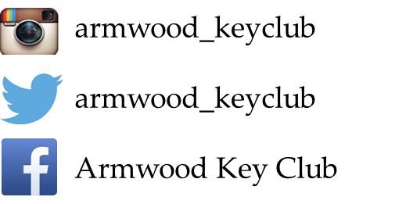

http://armwoodkeyclub.weebly.com/
https://groupme.com/join_group/11947655/SI5osI
Text ahskeyclub to 81010

